DAD 220 Project Two

1- Begin by writing SQL commands to capture usable data (which you’ve preloaded into Codio) for your analysis.

2- Specifically, the product manager wants you to analyze the following:

* Analyze the number of returns by state and describe your findings in your report.

ANSWER:

-> SELECT Customers.State AS STATE, COUNT(*) AS RETURN_FREQUENCY,

-> FROM Orders INNER JOIN RMA ON Orders.OrderID = RMA.OrderID

-> INNER JOIN Customers ON Customers.CustomerID = Orders.CustomerID

-> GROUP BY STATE

-> ORDER BY RETURN_FREQUENCY DESC;

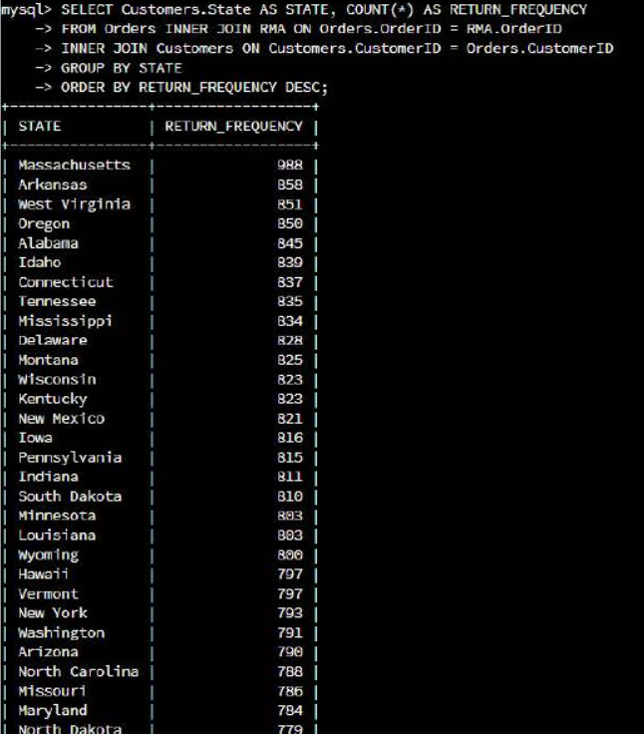

* THE HIGHEST RETURN FREQUENCY STATES ARE Massachusetts, Arkansas and West Virginia.

* THE HIGHEST RETURN FREQUENCY PRODUCTS WERE BAS-48-1C (returned 8422 times), ENT-48-40F (returned 6213 times) and ENT-48-10F (returned 4345 times).

* Analyze the percentage of returns by product type and describe your findings in your report.

ANSWER:

-> SELECT Customers.State AS STATE

-> (COUNT(*) 100/(SELECT COUNT (*) FROM Orders INNER JOIN RMA ON Orders.OrderID = RMA.OrderID)) AS RETURN_PERCENTAGE

-> FROM Orders INNER JOIN RMA ON Orders.OrderID = RMA.OrderID

-> INNER JOIN Customers ON Customers.CustomerID = Orders CustomerID

-> GROUP BY STATE

-> Order BY RETURN_PERCENTAGE DESC;

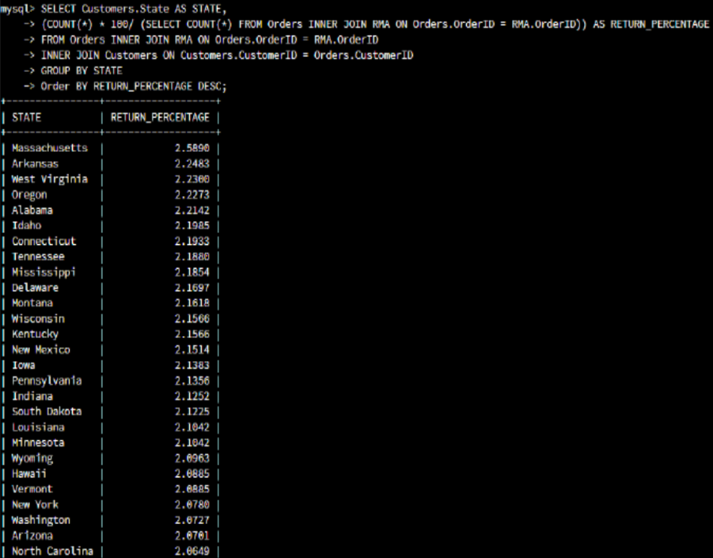

* THE STATES WITH THE HIGHEST RETURN PERCERNTAGE WERE Massachusetts, Arkansas and West Virginia.

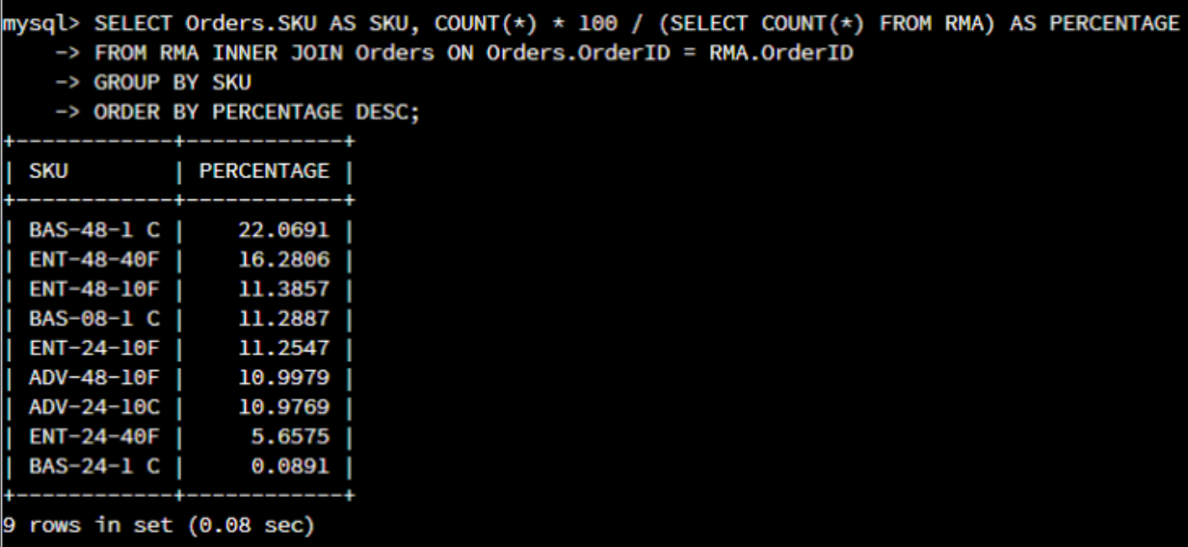

THE PRODUCTS WITH THE HIGHEST PERCENTAGE WERE Bas-48-1 (22.0691%), ENT-48-40F (16.2806%) AND ENT-48-10F (11.3857%).

3- In your report, clearly summarize your analysis of the data for stakeholders. Include screenshots of the results of each query. When summarizing results, you may want to consider the following questions:

* How does the data provide the product manager with usable information?

ANSWER: By identifying the locations with the best returns, the data obtained facilitates further investigation into the causes behind this. The product manager may utilize this information to comprehend sales patterns and product returns, which will allow them to determine the causes of returns and make the required corrections. Additionally, the firm can use this knowledge to adjust to possible product problems.

* What are the potential flaws in the data that has been presented?

ANSWER: Inaccurate data in data reports may result from the information given's lack of clarity on the causes of product returns or whether several goods came from the same customer.

* Are there any limitations on your conclusions, or any other ways of looking at it that you haven’t considered? Clearly communicate your findings to stakeholders.

ANSWER: One of the constraints may be the necessity for a more thorough examination to determine the issue with the item that has the highest return percentage for each state. The information gathered suggests that Massachusetts looks to have a large number of returns. The Basic Switch 10/100/1000 BaseT 48 Port is the product with the highest rate of returns. This proportion might decrease if further information could be obtained regarding the reasons behind returns and potential fixes.